Thematic Lunch

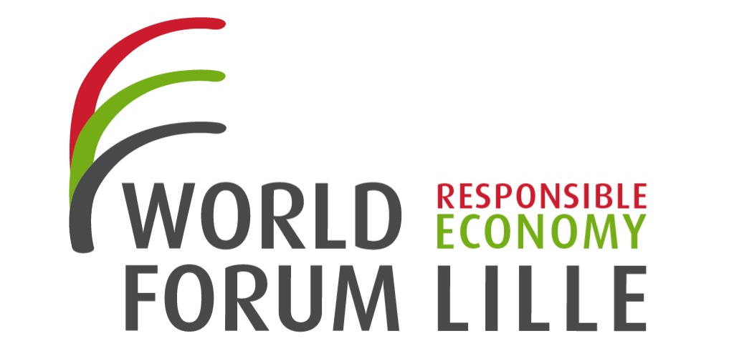

Thematic lunch 12I : ‘The transformational company’ 25/10/2013
e

BACKGROUND

The Transformational Company framework is being developed as a guide for companies who recognize the need to scale up their CSR and sustainability efforts in order to address systemic societal risks, challenges and opportunities. These qualities are designed to be aspirational and inspirational – to act as a roadmap.
This framework represents a global consensus on the new standard for sustainability in Canada and beyond; the consensus highlights the emergent need for companies to rethink their core purpose and customer offerings, to focus their efforts on solutions to systemic social, economic and environmental problems and to going beyond “zero harm” to creating net positive social and environmental benefits.

SYNTHESE DES DEBATS

What, how, who
Transformational business is a notion which questions the system. It’s not only about making a list of little ideas that can add up to each other and out of which will appear a plan: we have to operationalize ideas.
CBSR has 3 principles to build such a plan: What you do, how you do it, and who you interact with.
What you do must have sustainable purpose, solutions oriented.
How requires long term vision, sustainability governance and culture, etc.
Who you interact with : customer engagement, industry standards, public engagement etc.

Before building a CSR plan you must think for example: “Who do I engage with about this plan? My clients ? The other companies? Governments?”
For the plan to be sustainable a change of culture is mandatory. But it can also deal with governance: who has to set up the CSR plan? If the CEO is in charge of it he might be tempted to focus only on profits it might create.
=> This is why a new person “outside of the system” and the hierarchy has to change the plans at every stage of the business.

Environment and business are compatible

One might think that the environment and the commerce have two different logics, because commerce often requires higher volumes and therefore companies want to increase the size of their sales. For example Michelin wanted to sell the most tires possible whereas the consumers wanted to buy the least. However it is possible to combine both logics : they will now sell tires per kilometer, and not per product. Thereby everyone will have the same aim: sustainable products, and less volumes.
CSR is an opportunity not a constraint

CSR is not against the business, it is business. Any company which doesn’t adapt to the new market will die within five, ten or fifteen years. If companies do not anticipate the change the policy makers will force them to. CSR must not be seen as a 360 u-turn, but more like a necessary evolution which can lead to new opportunities – despite the fact that the possible profits can’t always be measured.

ILS L’ONT DIT
Indiquer ici les phrase-clés, les citations à retenir, les formules choc mentionnées durant la conférence
« texte de la citation » Initiale prénom Nom entier, nom de l’entreprise (ex : E. Laville, Utopies)

Thematic lunch organized by :

CBSR

CBSR is a non-profit member organization founded in 1995 which help and spur CSR programs in hundreds of Canadian companies.

http://www.cbsr.ca

Moderator of the lunch :

Steven Fish, executive director of CBSR.

Reporter
Paul-Marie MUNIER
Sciences Po Lille

