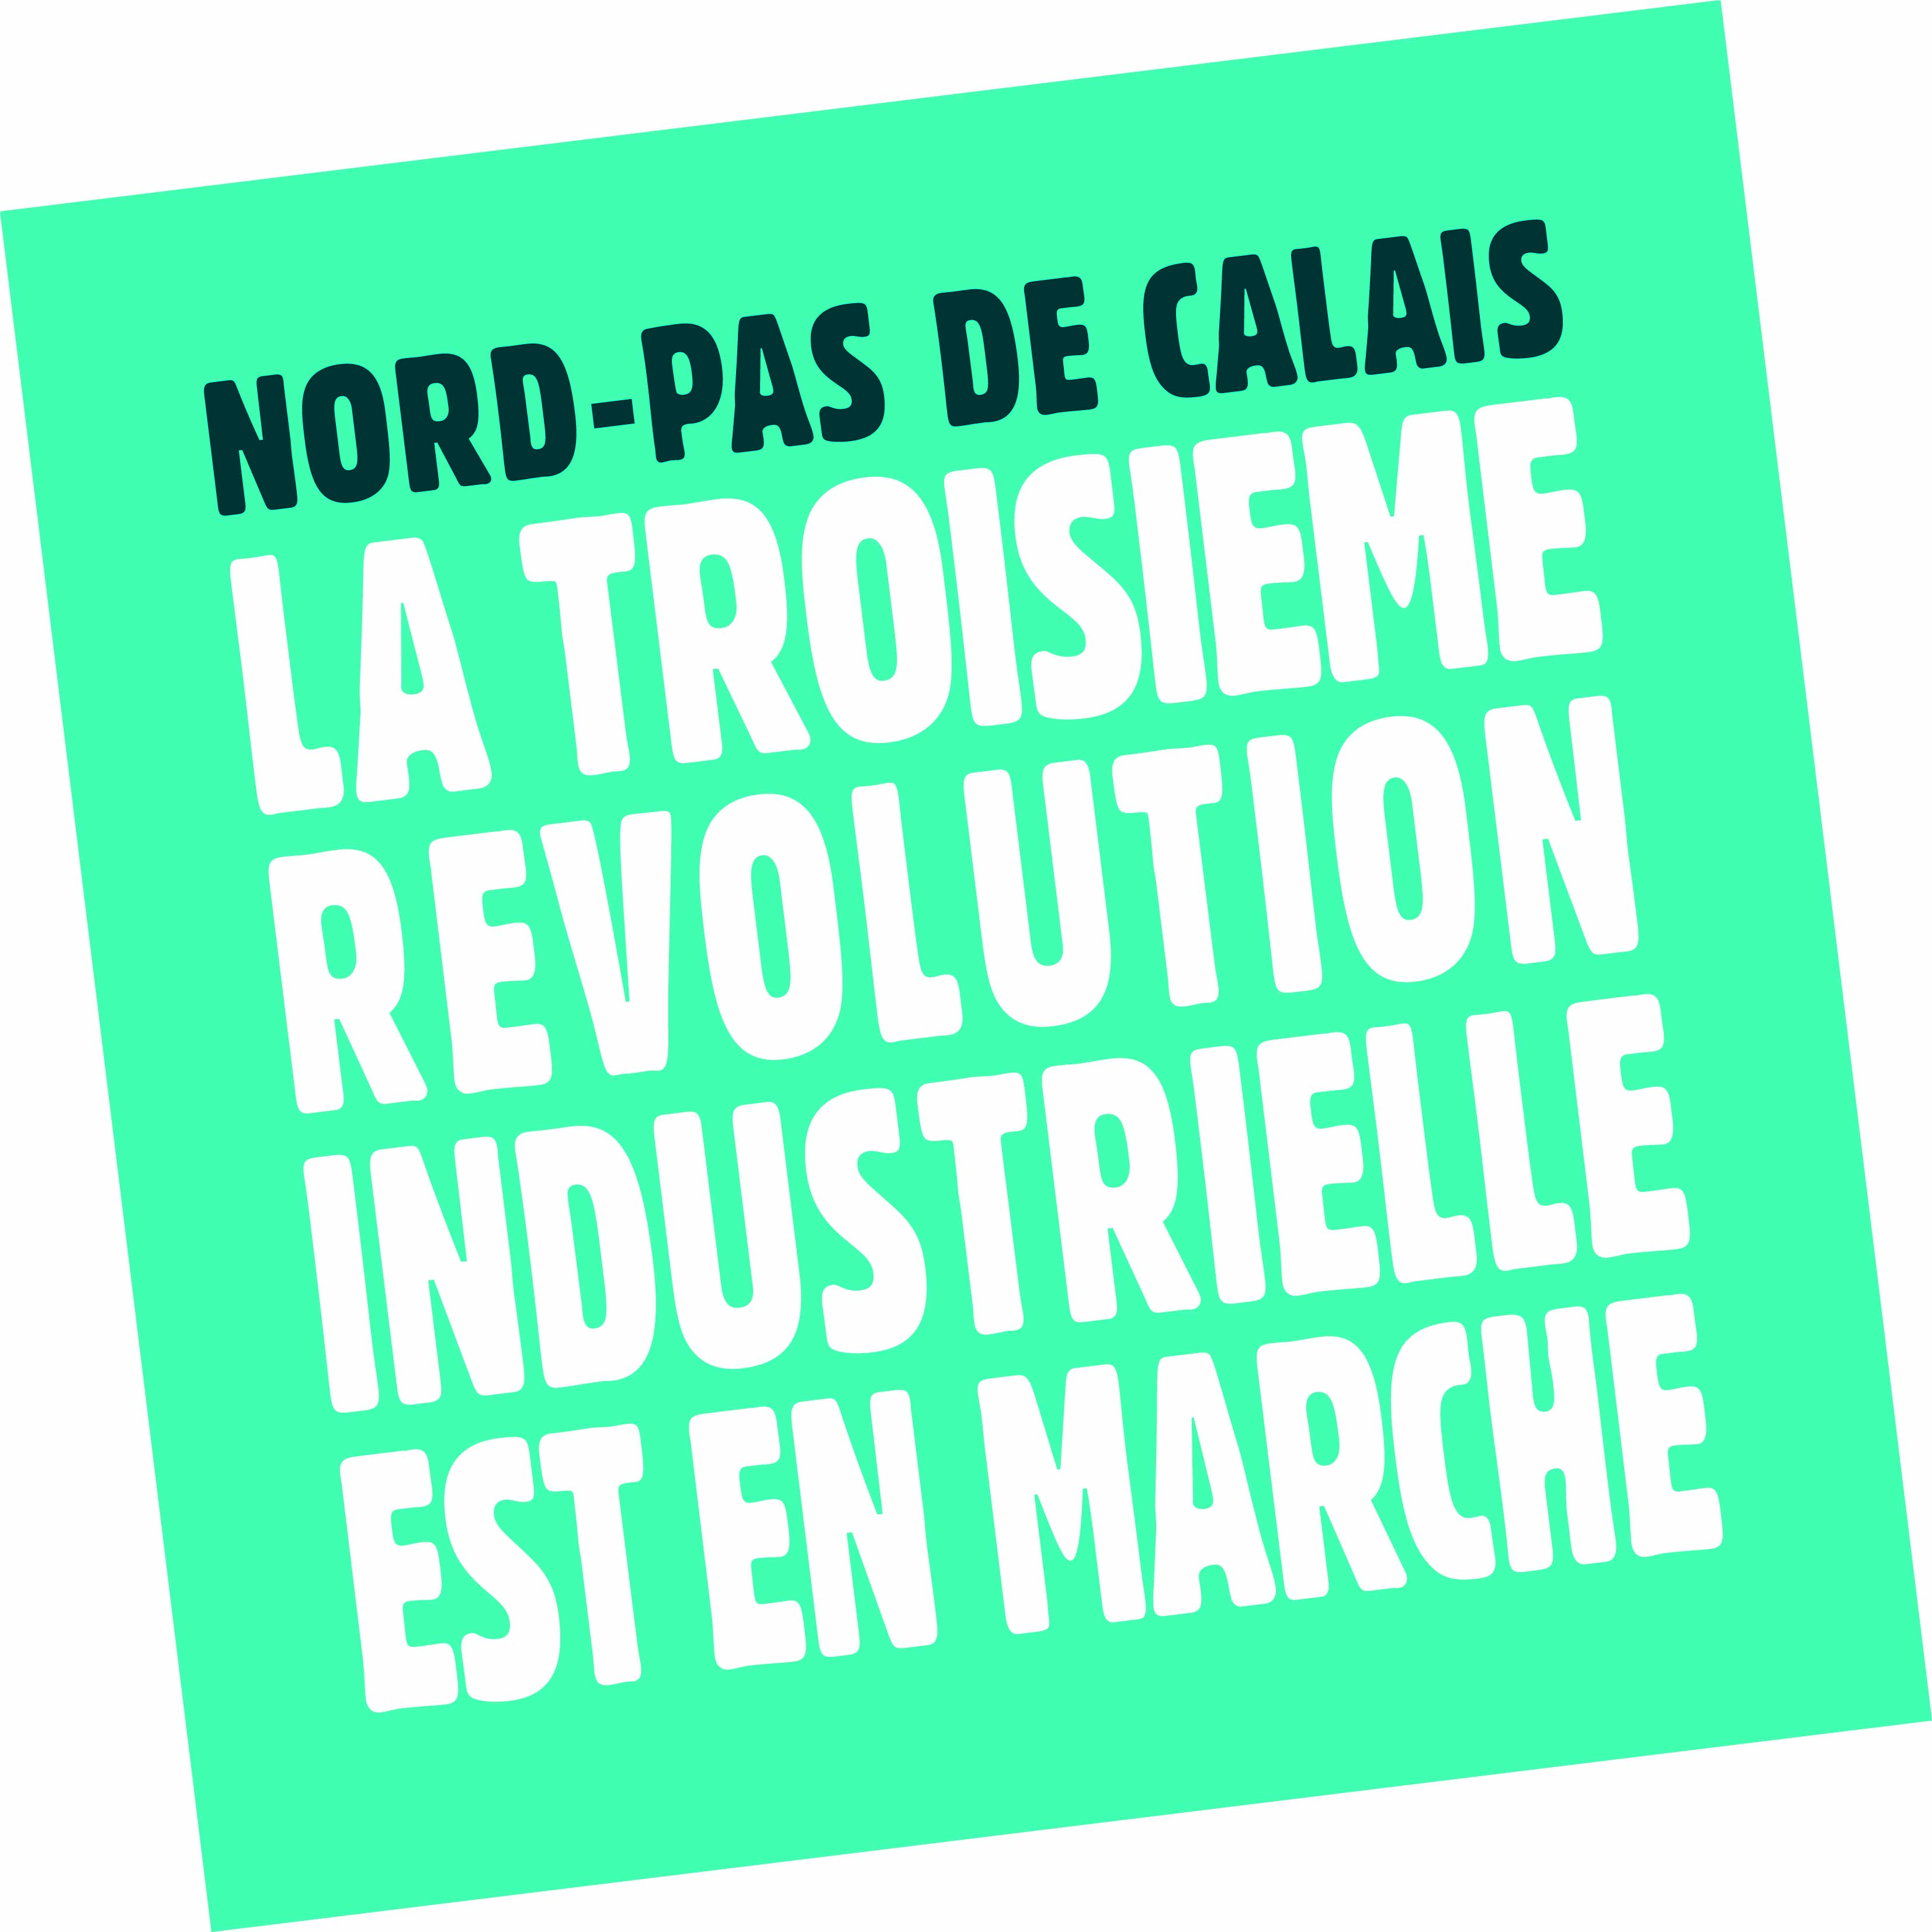
PRESS RELEASE
15th of May 2013

Nord-pas de calais
THE THIRD INDUSTRIAL REVOLUTION HAS ALREADY STARTED

cloSING SESSION concluding THE SEMINAR HELD IN LILLE WITH JEREMY RIFKIN:

nord-pas de calais: A leading region in the progressive strategy TOWARDS A carbon-FREE economy

In November 2012, the regional Chamber of Commerce and Industry and the Nord-Pas de Calais regional council asked Jeremy Rifkin to take part in designing a roadmap to lead Nord-Pas de Calais towards the third industrial revolution. It was a first in France.
On the 15th of May, after spending three days thinking together and debating passionately, regional political and economic players and Mr Jeremy Rifkin’s teams closed the seminar that brought them together in Lille. It is a crucial step in the design of the Masterplan defining the guidelines that will enable the region to build its third industrial revolution resorting to the five pillars, as well as to energy efficiency, circular economy and function-based economy. This Masterplan will be unveiled publicly on the 25th of October, during the World Forum in Lille.

DISCUSSIONS BETWEEN THE nord-pas de calais WORKING GROUPS AND jeremy rifkin’S EXPERTS
These three days of intense work and fruitful discussions between the Nord-Pas de Calais region and Jeremy Rifkin’s teams of experts made it possible to overcome the cultural choc and to share a global approach regarding the leads that Nord-Pas de Calais should follow in order to progressively move towards a carbon-free economy that will create new activities, thus bringing growth and employment.
The working groups enabled more than 125 persons to:
- Compare different viewpoints from European and international experts, with a specific focus on renewable energies, smart grids and energy storage
- Share middle-term and long-term perspectives for the Nord-Pas de Calais region
- Reach a consensus on issues such as the need to set up demonstrators and pilot projects on the short-term
- Draw the first common guidelines that have to be followed in order to implement the Masterplan, with a particular focus on energy efficiency with John Skip Laitner…

PILOT PROJECTS AND ‘DEMONSTRATORS’ WILL BE set up WITH the nord-PAS DE CALAIS REGION AS OF NEXT OCTOBER
During this seminar, all players realised that it was crucial to demonstrate straight away how relevant these ideas were, and to find leading projects that will pave the way.
This is why it is essential to quickly set up, at regional level, ‘demonstrators’ and pilot projects to be used as laboratories, to concretely test the ideas and their organisational as well as operational dimensions in particular…
As a result, the official presentation of the Master Plan on the 25th of October, during the World Forum in Lille, will come with public as well as private initiatives taken to concretely lead Nord-Pas de Calais towards the third industrial revolution.

nord-pas de calais CALLS FOR THE ‘RIGHT TO EXPERIMENT’…
With this type of projects, it is sometimes necessary to be able to have, at some point, the right to work without strictly following the regulatory frame. In order words, having the right – for a given time – to experiment, in order to launch innovative approaches and to test new solutions.
This is something which working groups (renewable energy and energy storage ones in particular) called for. They also recommended more stability in regulations in order to encourage investors to finance innovative projects and new economic activities.
This is why, during this seminar, Nord-Pas de Calais asked for dedicated, regional, experimentation labs, which would be in line with a decentralised approach. This could be done for regulations regarding heavy goods vehicles or motorway management, for example, but also for technological and territorial projects that carry innovation.

….AND SUGGESTs CREATING A FINANCIAL TOOL DEDICATED TO THE THIRD INDUSTRIAL REVOLUTION
In order to finance this project, the Nord-Pas de Calais region counts on several types of funds:
- European ones (ERDF, EIB, one billion euro as part of the European Union regional policy…),
- French ones (François Hollande and its government recently decided to invest 10 billion euro, Public Investment Bank…)
In addition to that, Philippe Vasseur, the president of the Nord de France region CCI and chair of the World Forum in Lille, suggested creating a financial tool dedicated to the third industrial revolution and to investing in companies working in this field. This tool would be supplied by regional savings: 1% would for example represent 2 billion euro.

VERBATIM: WHAT WAS SAID DURING THIS SEMINAR
- “What we are going to do here in Nord-Pas de Calais will make Europe evolve” Jeremy Rifkin
- “This is the first time that the whole region moves towards a common goal, showing deep and total cohesion” Daniel Percheron, president of the Nord-Pas de Calais regional council
- “The third revolution has started everywhere, but in a heterogeneous way. We are different because we want to work in an organised way in order to turn Nord-pas de Calais into a pilot territory, a lab that that will launch, as of 2014, concrete actions to create activities and employment” Philippe Vasseur, president of the Nord de France region Chamber of Commerce and Industry, chair of the World Forum in Lille
- “This project is different from other master plans because of its bottom/up approach that makes it easier to commit to it” Jean François Caron, regional counsellor and vice-president of the orientation forum
- “This region is a logistic European hub, it’s a great asset” Jeremy Rifkin
- “With the Nord-Pas de Calais region, we will show the rest of the world what we can do, and we will do it very soon” Jeremy Rifkin
- “Mister Rifkin, you are a fantastic accelerator to drive the transformation process in this region” Jean François Caron, regional counsellor and vice-president of the orientation forum
- “This revolution will either happen collectively, or it will not be happen at all” Philippe Vasseur
- “You have a major role to play in Europe’s future, and you will pave the way. It is for you to show Germany that this can be done” Jeremy Rifkin
- “I am full of optimism; I was moved by your passion, your commitment, your expertise. This region has to lead the way towards the third industrial revolution” Jeremy Rifkin

Press relations contact persons:

Nord de France region Chamber of Commerce and Industry: Michèle Buinet Bonaly, (+ 33) 3 20 63 79 53, m.buinet@norddefrance.cci.fr

Nord-Pas de Calais regional council: Peggy Collette, (+ 33) 3 28 82 53 03, (+ 33) 6 75 93 38 28, peggy.collette@nordpasdecalais.fr

